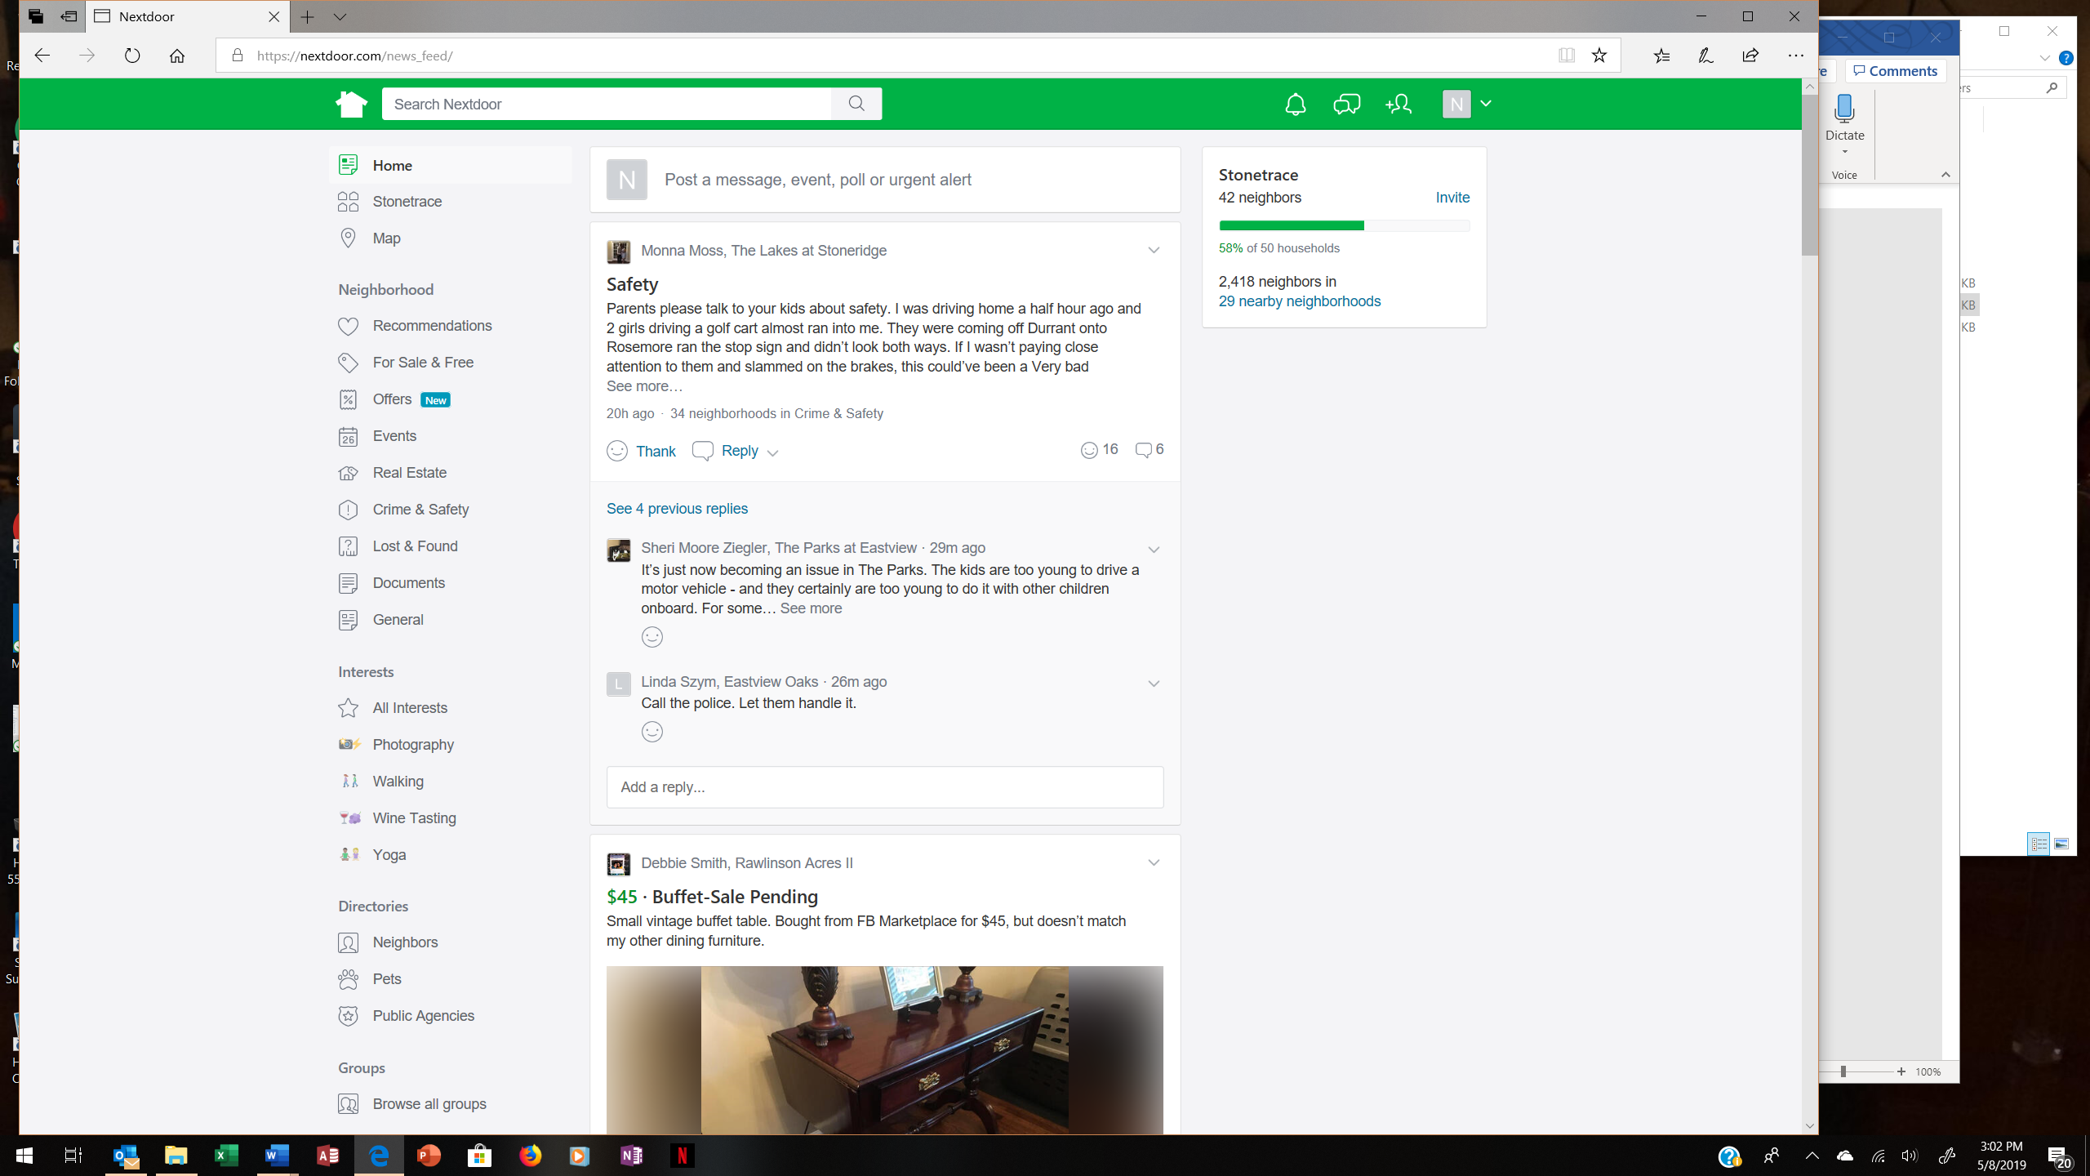**How to Join**

Give your email address to Polly Douglass or to another Stonetrace neighbor who is already a member. They will send you an email invitation via Nextdoor. You must be a verified resident of the Stonetrace community.

**Choose Your Neighborhoods**

You have the option under Settings to allow posts from many different neighborhoods in the Rock Hill area that are on Nextdoor. When you navigate to the Nearby Neighborhoods option, it will show you a map of the available neighborhoods so you can choose which ones you want to see.

**Posts**

When posting a message, be sure to post it under the appropriate Neighborhood or Interests category. If a posting is not in the right category, it may get reported and removed. Keep in mind, all the neighborhoods you chose when creating the post can report your content – not just your neighbors in Stonetrace.

Be sure to check the categories under Interests and follow and contribute to your favorites!

There will also be sponsored ads posted. The title of the ad is followed by the word “sponsored.” You can hide the ads, but there is not a way to block them from appearing initially.

**Neighbors Directory**

This is a directory of your neighbors and a means to private message anyone in the neighborhood who is on Nextdoor.

**Pets Directory**

Nextdoor is an excellent tool for identifying lost pets! Be sure to upload your pet’s picture in the My Family section of your profile. If you should see a pet that you do not recognize, this is a great way to quickly find out if it belongs to someone in Stonetrace. Just click on Pets under Directories in the left-hand menu.

**Public Agencies Directory**

See posts from these public service agencies currently on Nextdoor:

* National Weather Service South Carolina
* York County Government
* York County Office of Emergency Management

**Groups**

Groups provide a way for people who share common interests to communicate. You can create any kind of group and include members from any neighborhood. Examples of groups are card players, parents of toddlers, exercised buddies, etc. The group can be made public or private.

**SMS**

Under SMS in Profile & Settings, you can opt to get text messages on your cell phone. This is for urgent alerts only!

*If you still need more information about Nextdoor, links to Help and Guidelines are at the bottom of the left-hand menu.*